**Exercise1:**

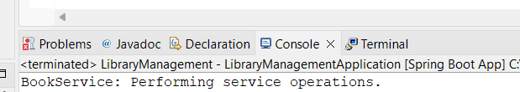

**Exercise2:**

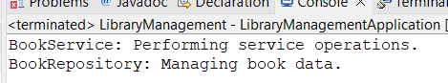

**Exercise3:**

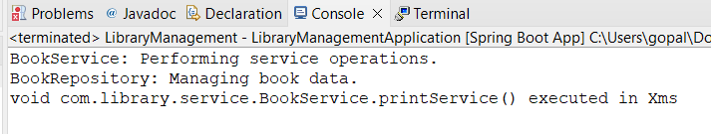

**Exercise4:**

There is no runtime output for this exercise as its just a setup.

**Exercise5:**



**Exercise6:**



**Exercise7:**



**Exercise8:**



**Exercise9:**

GET http://localhost:8080/api/books

[

{

"id": 1,

"title": "Spring in Action",

"author": "Craig Walls"

},

{

"id": 2,

"title": "Clean Code",

"author": "Robert C. Martin"

}

]